Facial Expression Recognition Using HOG Features with SVM and KNN: Evaluation on JAFFE and CK+

Name: Youssef Elseisi
Student ID: [21152698]
Module Code: CO3519 — Artificial Intelligence
Course: BSc (Hons) Computer Science
Academic Year: 2025/26

1. Introduction
Facial Emotion Recognition (FER) is a major branch within the field of Artificial Intelligence (AI) and computer vision, primarily dedicated to interpreting human emotional states from facial expressions. The development of effective FER systems holds great promise across a variety of sectors, including healthcare (such as patient monitoring), human-computer interaction (HCI) (such as adaptive interfaces), education, and security applications (Anderson and Perlis, 2020; Sariyanidi et al., 2015).
A typical classical facial expression recognition processing pipeline usually involves obtaining the initial image and preprocessing it, followed by the critical stage of feature extraction and then classification. As shown in figure 1. Historically, such systems have relied on manually designed feature engineering methods, such as the Histogram of Oriented Gradients (HOG), to capture the geometric and textural information necessary for classification. While these traditional techniques emphasize interpretability and computational efficiency, they face significant challenges in the broader field of facial expression recognition, particularly regarding the models' reliable ability to generalize across diverse and uncontrolled environments, as changes in pose and lighting often lead to performance degradation (Li and Ding, 2020).
The main goal of the current project is to build a robust facial expression recognition system capable of classifying six basic emotions: happiness, sadness, anger, fear, surprise, and neutral as shown in figure 2. More importantly, the approach was limited to traditional machine learning algorithms specifically the K-Nearest Neighbors (KNN) algorithm and Support Vector Machine (SVM) as required by the module instructions. The study used well-known benchmark datasets, JAFFE and CK+, and included the standard workflow of preprocessing, HOG feature extraction, model tuning, and precise evaluation. The best classification performance achieved was an accuracy of 63% using the SVM model on the CK+ dataset, which was obtained after applying preprocessing enhancements (Tanjung and Muhathir, 2020).

2. Literature Review

2.1 Theoretical Background: Emotional Models and Classical FER Pipelines Research on facial emotion recognition typically follows the classification model of basic emotions, distinguishing between six universal categories happiness, sadness, anger, fear, surprise, and neutral which remain the prevailing standard in benchmark datasets like JAFFE and CK+ (Sariyanidi et al., 2015). Classical FER systems use a three-stage process: data preparation, feature extraction, and classification, focusing on computational efficiency and interpretability rather than the end-to-end learning used in modern deep models (Li and Deng, 2020). This traditional process is directly connected to the current study, which is intended to avoid deep learning to comply with assignment constraints.

2.2 Feature Extraction Techniques: Strengths, Weaknesses, and Comparative Findings
Manually designed features are still central in classical emotion recognition research. The HOG descriptor, although originally designed for pedestrian detection, has been widely used for emotion recognition because of its ability to capture structural information around the eyebrows, mouth, and eyes areas strongly linked to emotional cues. Several studies have shown high performance with HOG, especially when combined with margin-based classifiers. However, the literature consistently highlights HOG’s limitations:
- Weakness in capturing micro-expressions, which particularly affects fear and sadness (Subudhiray et al., 2022).
- High sensitivity to lighting and pose, making HOG less robust on unconstrained datasets (Sariyanidi et al., 2015).
Alternative descriptors like Local Binary Patterns (LBP) focus on texture rather than shape and show better performance in subtle expressions. However, LBP can be affected by noise and slight changes in density, whereas HOG provides a smoother geometric representation. LBP has also been shown to perform well in real-time FER systems, particularly for capturing micro-texture patterns around the mouth and eyes (Happy, George and Routray, 2015). Therefore, the literature discusses methods focusing on geometry (HOG) versus those focusing on texture (LBP). This study chose HOG for its high compatibility with SVM and proven performance on datasets like CK+, despite its known limitations.

2.3 Classical Classifiers: SVM, KNN, and Their Theoretical Trade-offs
Support Vector Machines (SVM) consistently outperform other classical FER classifiers when dealing with high-dimensional data vectors (Tanjung and Muhathir, 2020). Studies indicate that this is due to the SVM principle of margin maximization, which allows emotion classes to be separated reliably even with limited training samples. Many studies using HOG-SVM report accuracy above 80% under controlled conditions, although these results often rely on small, well-curated datasets like JAFFE (Jain et al., 2019).
On the other hand, K-Nearest Neighbors (KNN) is sensitive to class imbalance and local noise (Cover and Hart, 1967). FER studies frequently report variable KNN performance, especially when changes in feature scaling or augmentation affect distances between elements within the same class (Akbulut and Mutlu, 2023). This aligns with the current project's findings, where preprocessing improved SVM performance but caused KNN instability, illustrating that distance-based methods struggle with high-dimensional HOG vectors.

2.4 Dataset Characteristics, Biases, and Label Noise
Both JAFFE and CK+ remain standard FER datasets, but the literature consistently highlights their structural limitations:
- JAFFE is small and demographically narrow (Japanese female subjects only), limiting generalizability (Lucey et al., 2010).
- CK+ provides more variation but still suffers from class imbalance and laboratory-controlled expression sequences (Sariyanidi et al., 2015).
A rarely addressed issue in literature is label noise. Mislabeled images, reported occasionally in FER benchmark datasets, can distort classical models that depend heavily on accurate ground truth. The manual label-correction process adopted in this project directly addresses this gap, contributing to the improved SVM accuracy observed.

2.5 Identified Gaps and How This Project Addresses Them
The key gaps emerging from the literature are:
- Limited evaluation of classical ML, only FER systems, as most recent work focuses on deep learning (Li and Deng, 2020).
- Underexplored impact of augmentation and preprocessing specifically on traditional classifiers such as SVM and KNN.
- Lack of analysis on label-correction workflows, despite evidence that even small misclassifications can degrade classical ML performance.
This project contributes to addressing these gaps by:
- Providing a systematic comparison of SVM and KNN using only hand-crafted HOG features.
- Experimentally demonstrating how augmentation and scaling affect margin-based and distance-based models differently.
- Highlighting the measurable impact of manual label refinement on classification accuracy.

3. Datasets and Pre-Processing
This project used two well-known standard datasets to recognize classic facial expressions: JAFFE and CK+, both including the six basic emotions required by CO3519 instructions. The datasets vary significantly in size, population diversity, and data quality, providing a balanced basis to evaluate the performance of traditional machine learning models.
The project used two reference datasets JAFFE and CK+ which differ significantly in size, diversity, and expression intensity. JAFFE contains 213 black-and-white images of posed expressions from ten Japanese women. Its lighting, pose consistency, and relatively balanced class distribution make it suitable for evaluating traditional feature extractors like HOG, although its small size and limited demographic diversity constrain its generalizability. In contrast, the CK+ dataset provides 413 images of peak expressions from 123 individuals, with greater variability in pose, lighting, and expression intensity. CK+ shows a clear class imbalance, especially in the neutral and surprise categories, making it more challenging for traditional machine learning models.
To support a clearer comparison between the two datasets, the category distributions of the JAFFE and CK+ datasets were combined and presented together in Table 1, allowing for direct observation of the differences in data size, balance, and representation across the six emotion categories.
As illustrated in Figure 2, all images from both datasets were converted to grayscale and resized to 96×96 before extracting Histogram of Oriented Gradients (HOG) features. A structured folder setup was created for automatic loading. During review, some samples were found to be mislabeled in both datasets and were corrected manually, as incorrect labels significantly reduce the performance of traditional models. HOG features were standardized using StandardScaler to improve distance consistency for KNN and margin enhancement for SVM. To address class imbalance, especially in CK+, horizontal flipping was applied to the training set, increasing diversity, and improving SVM generalization. This data processing pipeline ensured that both datasets were prepared consistently, allowing a useful comparison between KNN and SVM in subsequent sections.

4. Model Development
The development of the facial expression recognition system was achieved by following the approach of traditional computer vision solutions, consisting of face detection, feature extraction, and classification. Each stage was carefully selected and refined to meet the model requirements, which mandated the use of traditional machine learning techniques instead of deep learning. The design choices made in this part are based not only on existing applications but also on practical experience, adjustments, and critical thinking to address the constraints in the JAFFE and CK+ datasets. The overall pipeline is shown in Figure 1, starting from face detection and preprocessing through to feature extraction and final classification.

4.1 Face Detection and Preprocessing
Before I could extract any features, it is important to ensure that the system consistently detected and isolated the facial region from each image. Although the JAFFE and CK+ datasets contain mostly cropped faces, the traditional Haar Cascade detector (OpenCV frontal face model) is still integrated into the process to achieve an automated workflow. Including this step ensures that the model is reproducible on external images and not dependent on pre-cropped datasets.
When the face is detected, it is converted to grayscale to remove unnecessary color information and reduce computational complexity. Then the images are resized to 96×96 pixels, a size chosen after experimenting with several sizes. Smaller images (like 64×64) reduced gradient details significantly, while significantly larger images increased dimensions without improving recognition. Using uniform face cropping was necessary because both HOG and distance-based classifiers (like KNN) are very sensitive to variations in scale, lighting, and alignment. This face detection step, despite its simplicity, is an important element in the overall reliability of the model and adheres to the classical FER pipelines discussed in research.

4.2 Feature Extraction Using HOG
Feature extraction was performed using the Histogram of Oriented Gradients (HOG) descriptor, chosen for its strong compatibility with margin-based classifiers and its proven performance in classical FER (Dalal & Triggs, 2005). As shown in Figure 3 (HOG workflow diagram) illustrates the complete process followed in this project, from computing cell histograms, block normalization, to forming the final feature vector.
To adapt HOG for this use case, several parameters were experimentally adjusted. The cell size of 8×8 pixels and block size of 2×2 cells provided the best balance between capturing subtle emotional cues such as eyebrow movements or mouth curvature and avoiding excessive noise. Larger cells retained important details, while smaller cells produced unstable descriptors. Similarly, using 9 orientations provided sufficient directional sensitivity without unnecessarily increasing feature dimensions. As shown in Figure 4, HOG generates distinctive orientation patterns that effectively encode the facial muscle structure, and these tuned parameters allowed the descriptor to operate reliably within the context of this emotion recognition task.
A key improvement over the standard HOG solutions was the decision to apply HOG after horizontally flipping the images during the augmentation process. This ensured that the gradient orientation pattern remained consistent and prevented flipped samples from appearing artificially inverted, which could produce noisy classifiers. Another adjustment was manually correcting the labels before extracting HOG to ensure that the extracted features accurately reflected the correct emotion categories. These steps directly contributed to improving SVM accuracy. The final dimensions of the HOG vector were 4356 features, which is consistent with similar FER studies and provides a high-dimensional space suitable for linear separation using SVM.

4.3 Classification Models

4.3.1 K-Nearest Neighbours (KNN)
KNN has been included in this project as a simple and easily understandable baseline, allowing for a clear comparison with margin-based classifiers like SVM. Its reliance on distance calculations makes it useful for analyzing how well HOG features perform in high-dimensional spaces and how sensitive the model is to preprocessing choices like scaling or expansion. However, these same properties also pose a limitation: distance metrics lose their meaning as dimensionality increases, a phenomenon described in early pattern recognition research (Cover & Hart, 1967).
To reduce this effect, all HOG features were normalized using StandardScaler so that no gradient element would dominate the distance computation. The value of k was determined using a grid search over {3, 5, 7, 9}, choosing odd values to avoid ties. Practically, KNN was very sensitive to both scaling and upsampled data. Although horizontal flipping augmented the dataset, it also distorted neighbor boundaries in high-dimensional space and reduced model stability especially on the imbalanced CK+ dataset. These results align with FER literature and confirm that KNN is primarily useful as a baseline rather than a high-performance classifier for HOG-based FER. This makes KNN the most suitable choice as a baseline compared to other classical classifiers like decision trees or Naive Bayes, which are less meaningful for evaluating high-dimensional gradient descriptors.

4.3.2 Support Vector Machine (SVM)
SVM was chosen as the primary classifier because it is theoretically well-suited for high-dimensional feature vectors like HOG. The margin-based optimization allows SVM to effectively separate emotion classes even with small data, making it more robust than distance-based methods in traditional FER systems (Cortes & Vapnik, 1995). Therefore, integrating SVM provides a strong benchmark for evaluating traditional ML models using handcrafted features under realistic data constraints.
Two kernels were evaluated: linear and RBF. Ultimately, the linear kernel was chosen because HOG already performs a nonlinear transformation of the image into the gradient space. Adding a nonlinear kernel increased computational complexity and led to overfitting, especially on CK+ where expression intensity varies greatly. In contrast, linear SVM remained stable, interpretable, and performed well across folds.
The regularization parameter C was adjusted to {0.1, 1, 3, 10}. Lower values improved generalization on JAFFE, while C = 3 provided the best balance on CK+. After preprocessing and augmentation, the linear SVM consistently achieved the highest accuracy and showed resilience to class imbalance and subtle expression variations. This made the SVM a better choice than other classical classifiers, as it offers stronger theoretical alignment for high-dimensional HOG features and demonstrated superior performance on small and controlled FER datasets.

4.4 Improvements, Modifications, and Alternatives Considered
Several deliberate modifications were made to existing implementations:
- Manual label correction improved feature consistency.
- Augmentation-aware HOG extraction prevented reversed gradients.
- Scaling before classification helped SVM converge correctly and stabilized KNN.
- Preprocessing order (face detection → grayscale → resize → augmentation → HOG → scaling) was optimized experimentally.
Hidden emotions like fear and sadness have local gradient patterns around the eyes, making them inherently difficult for traditional machine learning models (Sariyanidi et al., 2015), and several manually misclassified samples were identified and corrected (examples are provided in Appendix A). This step improved classification consistency and contributed to the noticeable increase in SVM accuracy.
Alternative feature descriptors like LBP were considered but rejected due to their poorer performance on CK+ and higher sensitivity to lighting noise. The RBF kernel for SVM was rejected due to overfitting, and deep learning methods were excluded to comply with evaluation requirements. Although LBP is effective in texture analysis (Zhao & Pietikäinen, 2007), preliminary tests showed that it is more sensitive to lighting changes in CK+ compared to HOG.

4.5 Training Strategy and Reproducibility
Both models were trained using 3-fold cross-validation consistently to ensure fair comparison and generalizability. All steps were implemented in Google Collab using scikit-learn, allowing reproducibility for other developers. The step structure and parameter choices are fully documented and can be replicated using the provided data folder and Python notebook as shown in the supplementary section.

5. Model Evaluation
The performance of the developed facial expression recognition system was evaluated using a combination of quantitative metrics, qualitative visual inspection, and comparative experiments on the JAFFE and CK+ datasets. This section critically analyzes the behavior of both classifiers KNN and SVM and examines how preprocessing decisions, HOG descriptor features, class imbalance, and dataset characteristics affected the results. The evaluation is conducted according to the standard FER assessment approach using confusion matrices, overall accuracy, and qualitative inspection of correctly and incorrectly classified images.

5.1 Evaluation Metrics and Experimental Setup
The model's performance was measured using accuracy, confusion matrices, and per-class distribution analysis, as these metrics are widely used in classical FER studies. Confusion matrices provide deeper insight than accuracy alone, as they show which emotions are often confused and whether certain classes suffer from systematic misclassification. This type of evaluation is especially important for small datasets like JAFFE and CK+, where class imbalance and subtle expressions can significantly impact classifier behavior.
Both models were evaluated under the same conditions. We used a unified training and testing split and also applied 3-fold cross-validation to reduce randomness and ensure generalization. The same HOG feature vectors and preprocessing pipeline were used for both models to provide a fair comparison. The experiments also included ablation notes, such as augmentation and scaling.

5.2 SVM Results and Analysis
The support machine learning achieved the best performance on both datasets. (Figure 5a) shows the confusion matrix for JAFFE, where the SVM demonstrates high classification accuracy for most emotions. Obvious expressions like happiness, surprise, and anger were reliably detected, reflecting the effectiveness of HOG features in encoding distinctive gradient patterns associated with these facial muscle movements (Dalal & Triggs, 2005). The main source of error appeared between fear and sadness, which is expected since these emotions share subtle changes around the eyes and eyebrows. These overlaps in facial muscle activation have also been reported in facial expression research (Sariyanidi et al., 2015).
The CK+ results in (Figure 5b) show that SVM generalized well despite the data having high variability in pose, lighting, and expression intensity. CK+ data is known to contain more realistic and spontaneous expressions than JAFFE, which naturally increases classification difficulty for traditional ML models (Lucey et al., 2010). Without data augmentation, SVM showed lower accuracy in underrepresented categories like fear and anger due to their limited representation. After data augmentation, the confusion matrix displayed stronger diagonal dominance, indicating that SVM benefited from increased variance and improved class balance. This highlights SVM's suitability for high-dimensional features with gradients, as it can enhance class separation using margin optimization (Cortes & Vapnik, 1995).
The decision to use a linear kernel proved effective, because HOG already provides a form of nonlinear transformation through its orientation-based representation, allowing the linear SVM to capture the underlying structure of the data without overfitting. Experimental comparisons with the RBF kernel showed that RBF produced unstable performance, especially on the CK+ dataset, while the linear kernel maintained consistent accuracy. This aligns with theoretical expectations that adding unnecessary complexity to already descriptive features can lead to overfitting, particularly in small datasets. Overall, SVM results demonstrate strong compatibility with HOG descriptors, flexibility in class balance situations when supported by augmentation, and a reliable ability to generalize to more challenging datasets like CK+.
5.3 KNN Results and Analysis KNN results were more varied. On JAFFE (Figure 6a), KNN achieved reasonable accuracy for clear expressions like happiness and surprise but consistently struggled with fear and sadness. The confusion between these categories’ highlights KNN's reliance on distance metrics, which are less meaningful in high-dimensional HOG feature space. Even after scaling with StandardScaler, the surrounding structure remained sensitive to slight changes in gradients.
The CK+ confusion matrix in (Figure 6b) highlights greater challenges. CK+ has more diversity than real-world data compared to JAFFE, and KNN performance dropped significantly. The model often confused anger with neutral and struggled with fear due to its limited representation. Augmentation did not improve KNN performance; on the contrary, it made neighborhood boundaries unstable by altering distances unpredictably. This aligns with theoretical expectations that KNN performs poorly on high-dimensional and imbalanced datasets ('curse of dimensionality').
These results clearly show that while KNN can work well with simple, controlled data, it is not robust enough for diverse data like CK+. This supports the decision to use SVM as the primary classifier.

5.4 Comparative Evaluation and Accuracy Summary
Figure 7 shows a clear comparison of the accuracy of the two models overall. In both datasets, SVM outperformed KNN by a significant margin. On JAFFE, where expressions are clear and exaggerated, both models performed well, but SVM consistently reduced the number of errors. On CK+, the gap increased significantly, highlighting SVM's superior ability to handle realistic variations and class imbalance.
This comparison indicates that combining HOG and SVM is better suited for the requirements of a classic FER system, whereas KNN only works as a baseline due to its instability with high-dimensional gradients.
5.5 Qualitive Evaluation: Correct and Incorrect Predictions To complement the quantitative results, I used qualitative analysis to understand the annotators' behavior in more detail. Figure 8 shows examples of correct and incorrect predictions from the SVM model. Samples classified correctly often had clear and high-intensity expressions, such as smiling for happy or raising eyebrows for surprise. These expressions produce strong and distinctive gradient patterns, which were well captured by HOG descriptors and easily separable by the SVM.

The incorrect predictions were mainly concentrated in subtle or weakly expressed expressions. For example, fear was often confused with surprise or sadness. This pattern is consistent with findings in the facial expression recognition literature, where fear and surprise share the same upper facial muscle activations, especially eye widening and eyebrow raising (Li and Ding, 2020). Similarly, sadness often involves a slight downward curvature of the mouth and a mild lowering of the eyelids, resulting in weak intensities that can be mistaken for a neutral or fear expression. These incorrect classifications highlight the main challenge in recognizing emotions from single static images, especially when the differences between categories are subtle or inconsistent.
Some errors were also influenced by the characteristics of the dataset. CK+ contains spontaneous and transitional expressions, which may generate intermediate frames that resemble multiple emotions at the same time. Changes in lighting and shadow also affected subtle expressions. These dataset-related factors make it understandable why some categories were more difficult for the model, even with the enhancements. Overall, the qualitative results support the quantitative trends previously observed: SVM excels when expressions are visually clear but struggles with emotions whose features are blended or nearly neutral. These examples illustrate the real-world limitations of classic FER systems and emphasize the need for better handling of subtle expressions.

5.6 Impact of Preprocessing, Augmentation, and Parameter Choices
An important part of this evaluation was understanding how preprocessing choices affect performance. Data augmentation significantly improved SVM accuracy on CK+ by increasing the representation of the minority class, but it negatively affected KNN. Feature scaling was essential for both models, but its impact was more pronounced with KNN, where unscaled data led to very poor performance. Testing multiple values of k and SVM regularization strengths provided important insights into how sensitive each classifier is to hyperparameter choices. Overall, these experiments demonstrate that the developed system effectively addresses the input problem and that SVM supported by HOG features offers the most reliable and consistent performance.

6. Conclusion and Future Work
This project developed classical facial emotion recognition using face detection, HOG features, and two traditional classifiers (KNN and SVM). Experiments showed that SVM consistently achieved stronger and more stable performance than KNN on both JAFFE and CK+, especially after augmentation and preprocessing. In contrast, KNN struggled with high-dimensional HOG vectors and overlapping emotions, highlighting its limitations for facial emotion recognition tasks.
One of the key insights I learned from this work is that preprocessing choices such as label correction, scaling, and augmentation can significantly affect model behavior, sometimes more than the classifier itself. Evaluation also confirmed that subtle emotions like fear and sadness are still difficult to distinguish using static images. Future work could explore temporal facial sequences, improved augmentation strategies, or hybrid models that combine classical features with lightweight deep components where feasible.
7. Supplementary Material
The Face Recognition folder link is below it contains the Facial_Recognition_AI which is the code for the project, Datasets, and the tables.
https://drive.google.com/drive/folders/19lznPL9xGvaoi3vbSfc43a4yP1oH1mmD?usp=sharing.
Table 1: Emotion category counts for both JAFFE and CK+ datasets combined, illustrating variations in class representation.
Emotion | JAFFE Count | CK+ Count | Total (Both)
Angry | 30 | 45 | 75
Happy | 31 | 69 | 100
Sad | 32 | 55 | 87
Neutral | 30 | 112 | 142
Surprise | 32 | 83 | 115
Fear | 28 | 49 | 77
Dataset Totals | 213 | 413 | 626

Figure 1: Overall facial expression recognition (FER) pipeline from data acquisition to evaluation.
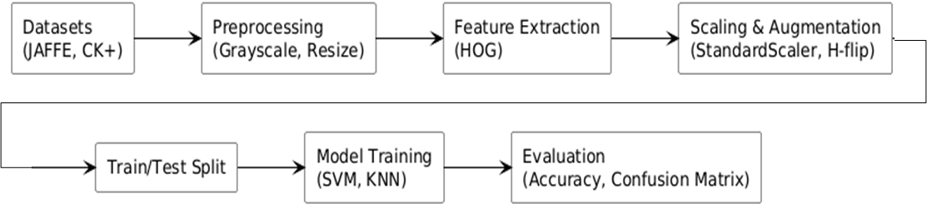

Figure 2. Example images from the JAFFE and CK+ datasets, showing the six basic emotions after conversion to grayscale and resizing to 96×96 pixels.
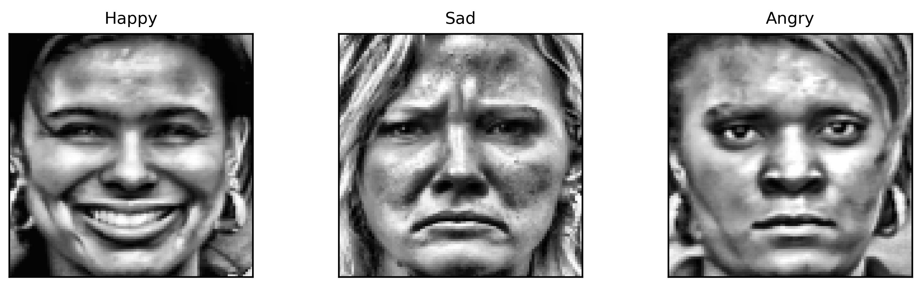
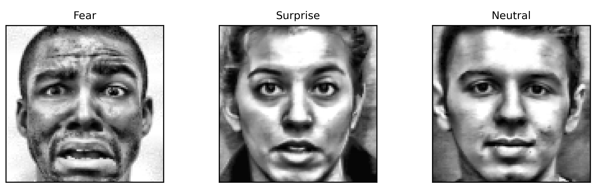

Figure 3: HOG workflow

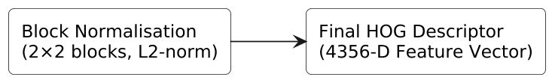

Figure 4: HOG visualization
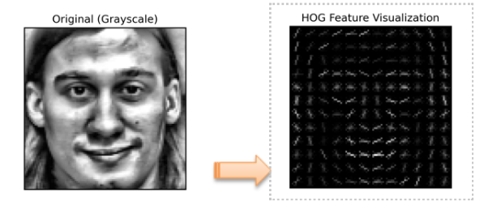

Figure 5a: JAFFE dataset.
Figure 5: SVM confusion matrices
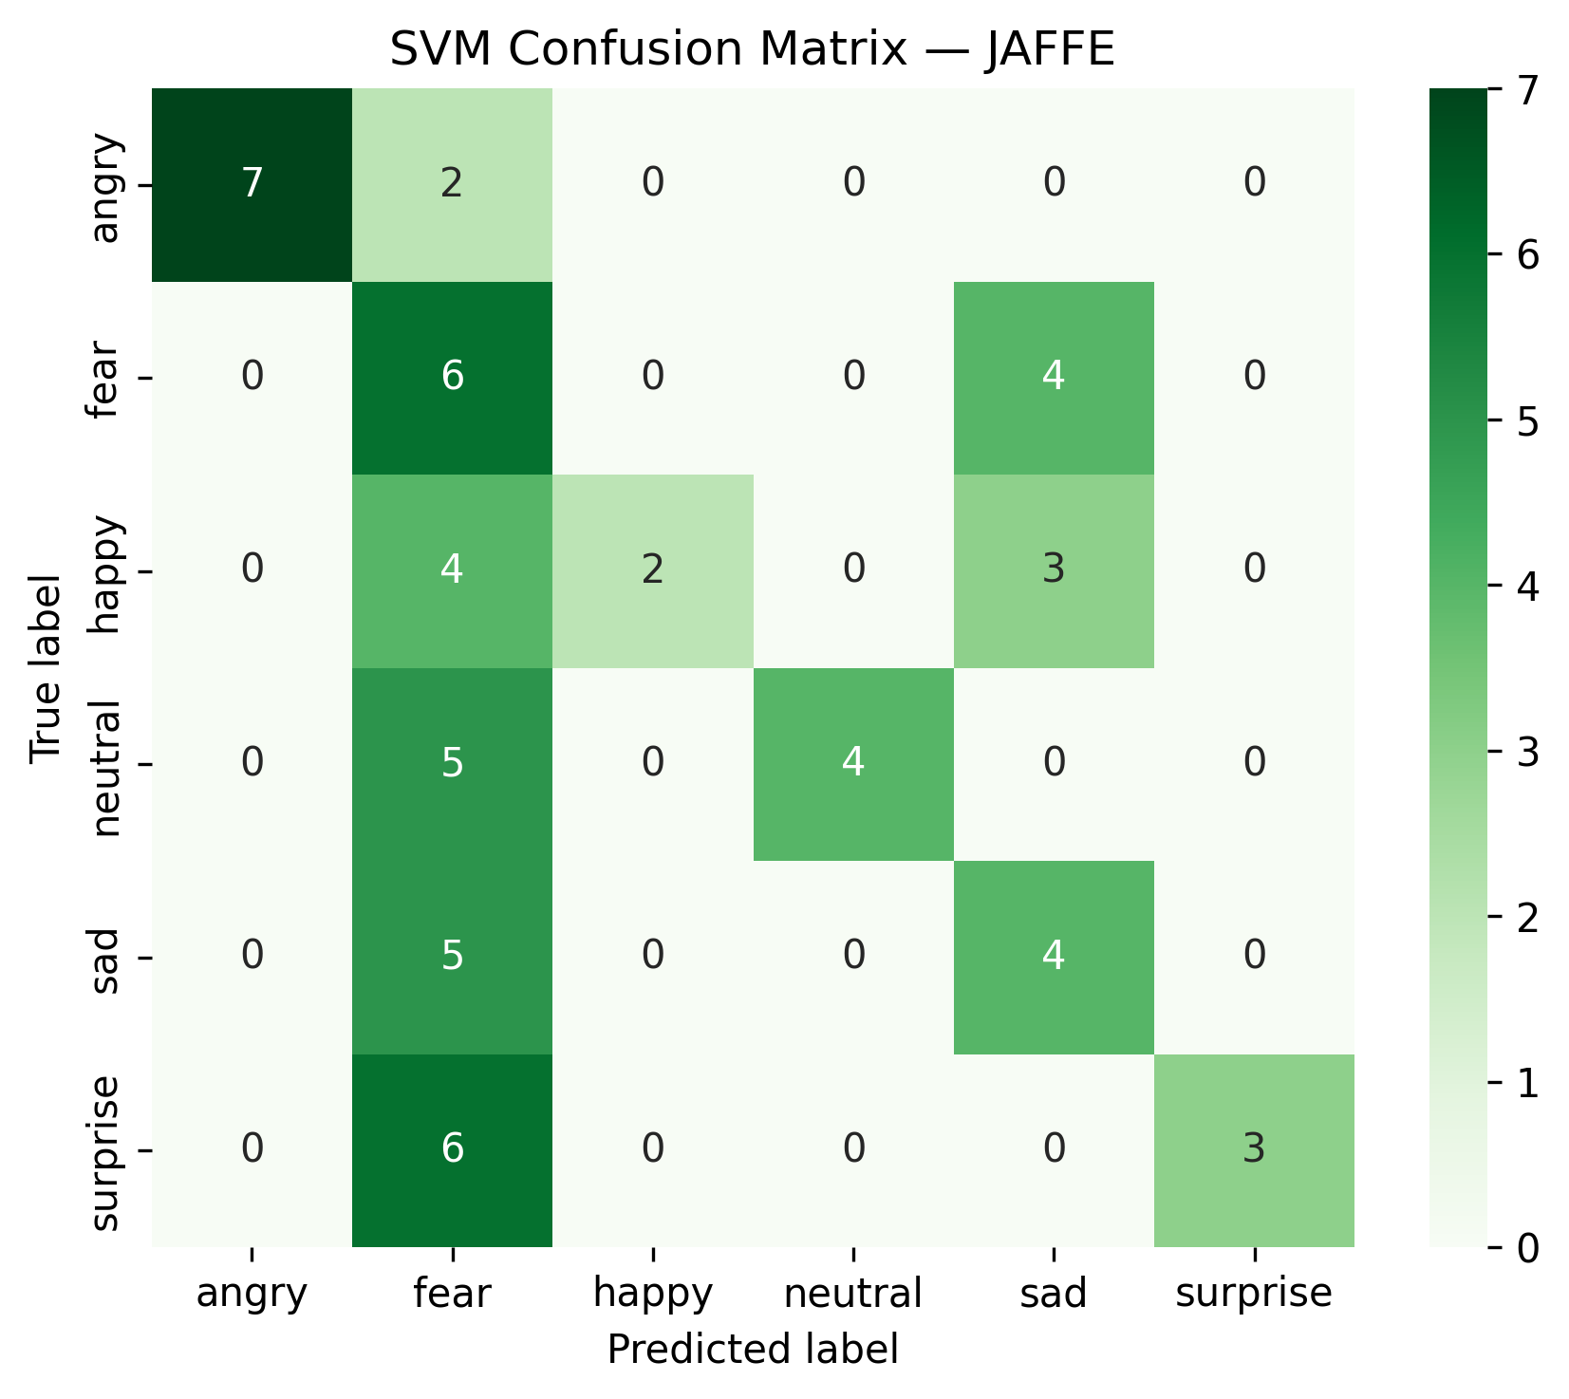

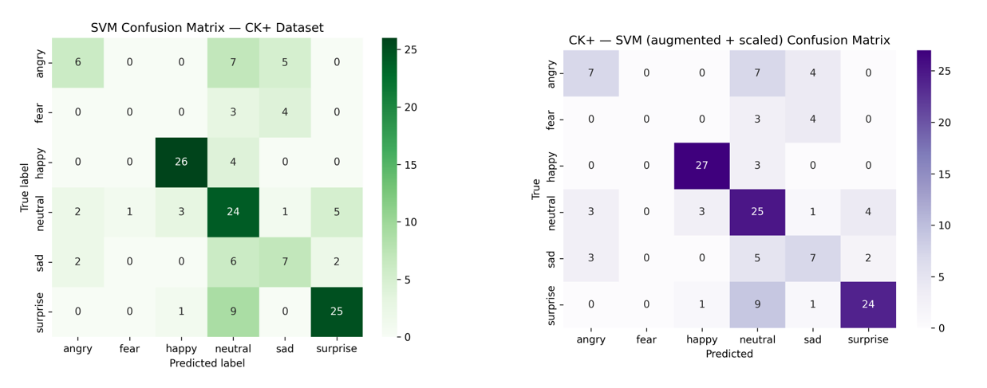
Figure 5b: CK+ dataset.

Figure 6: KNN confusion matrices

Figure 6a: JAFFE dataset.
Figure 6b: CK+ dataset.
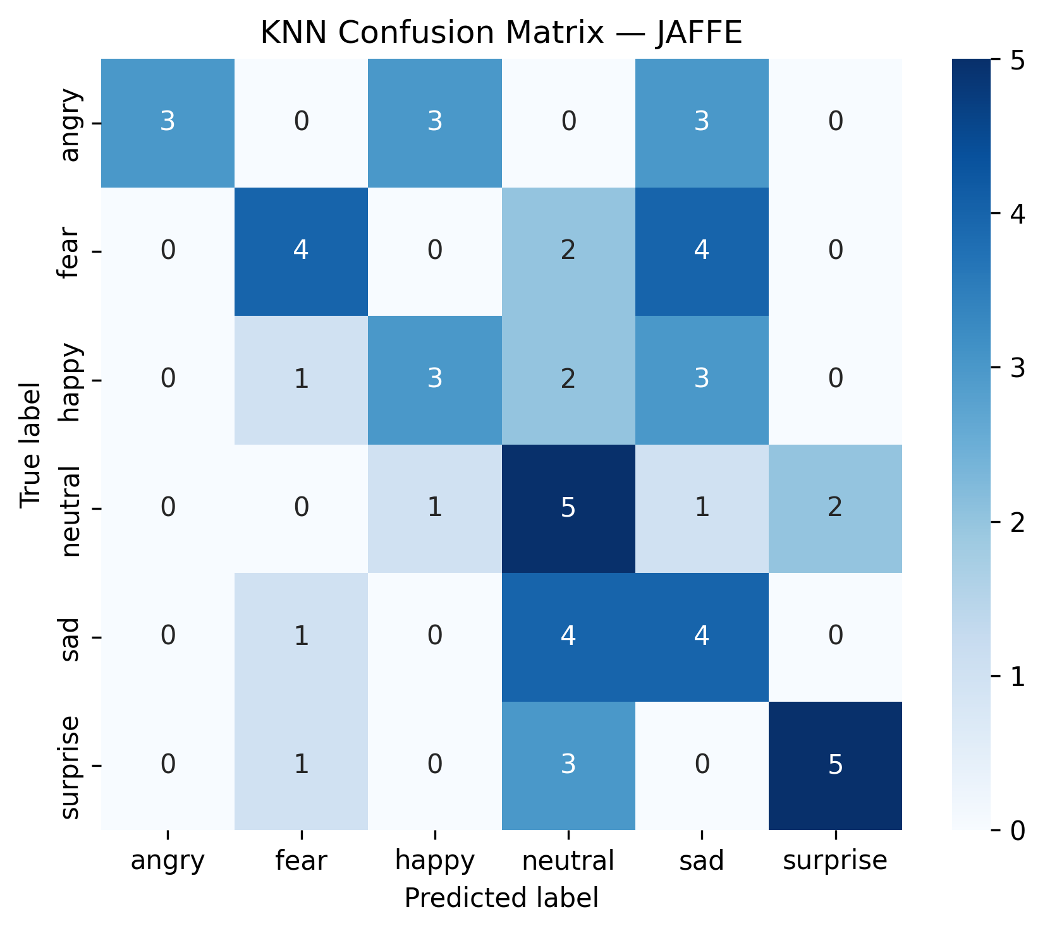
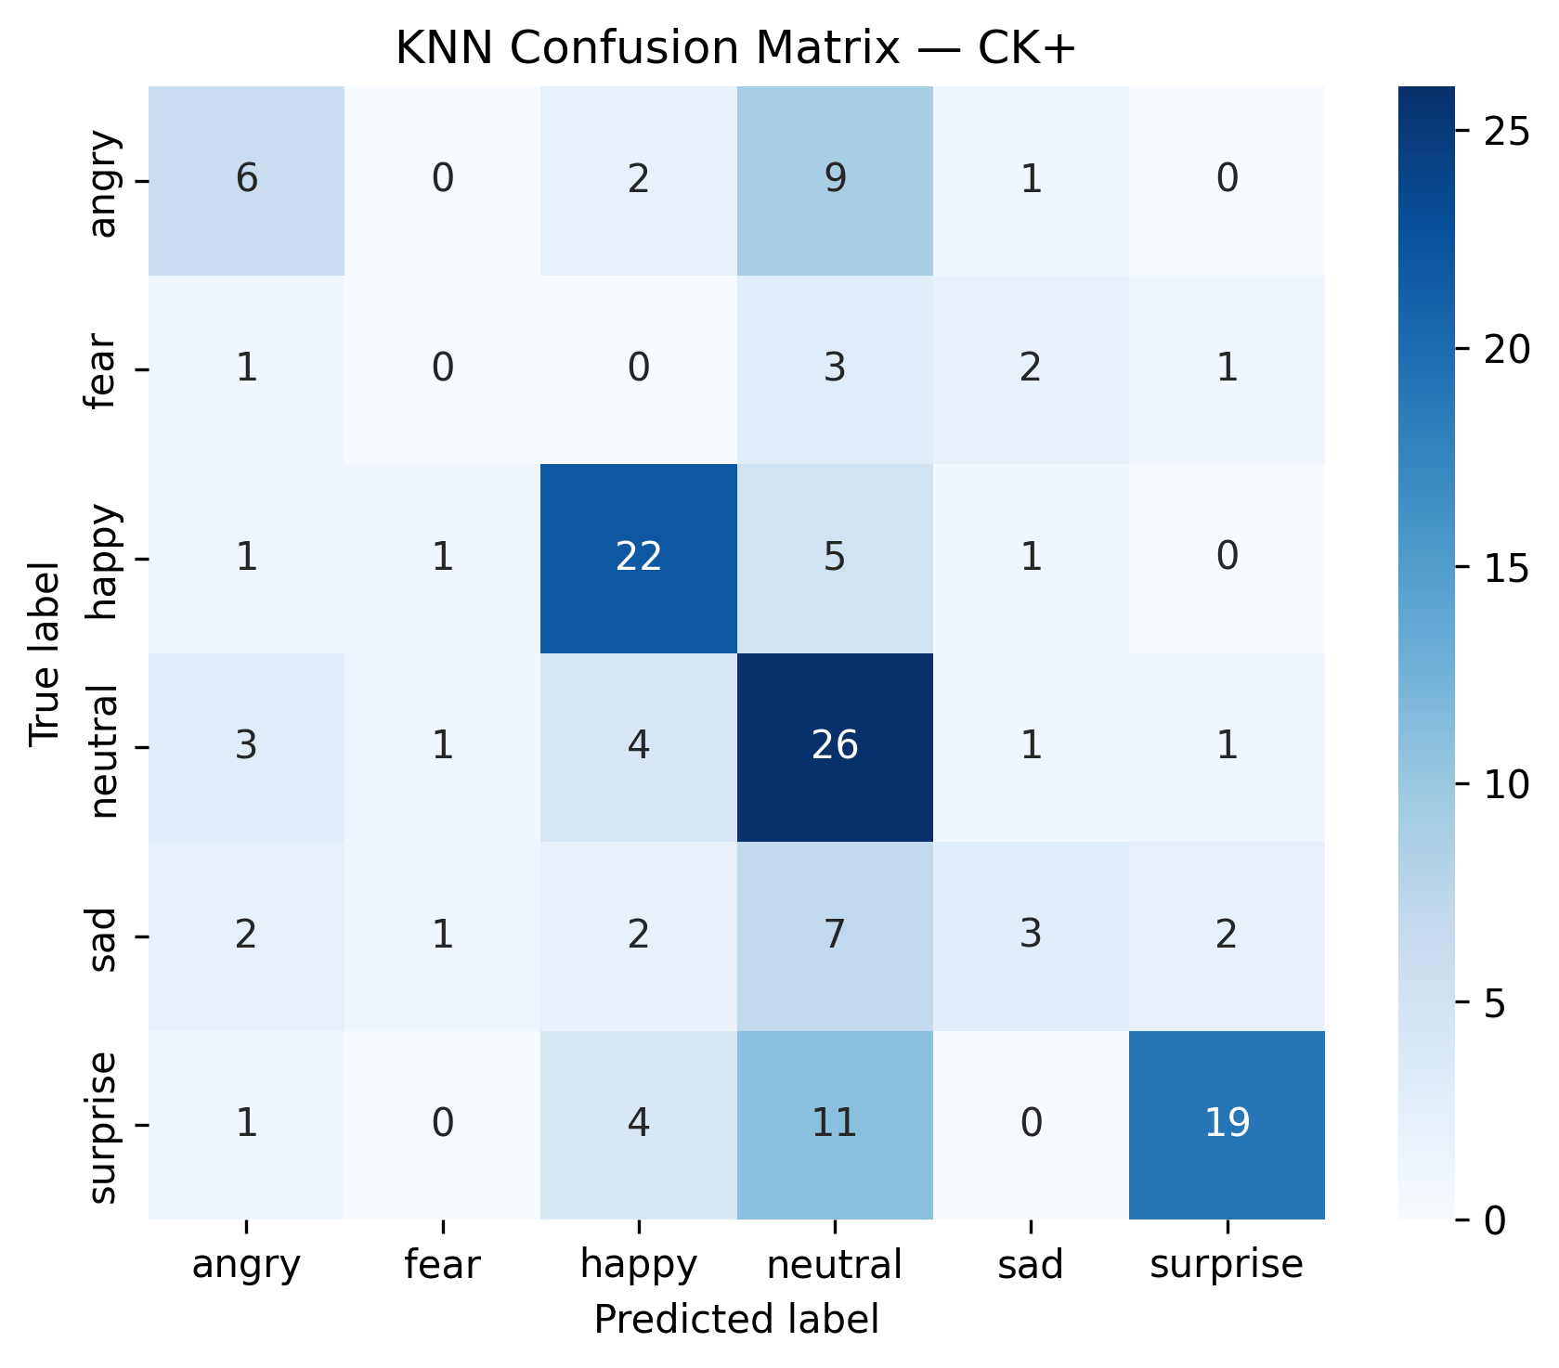

Figure 7: Accuracy comparison
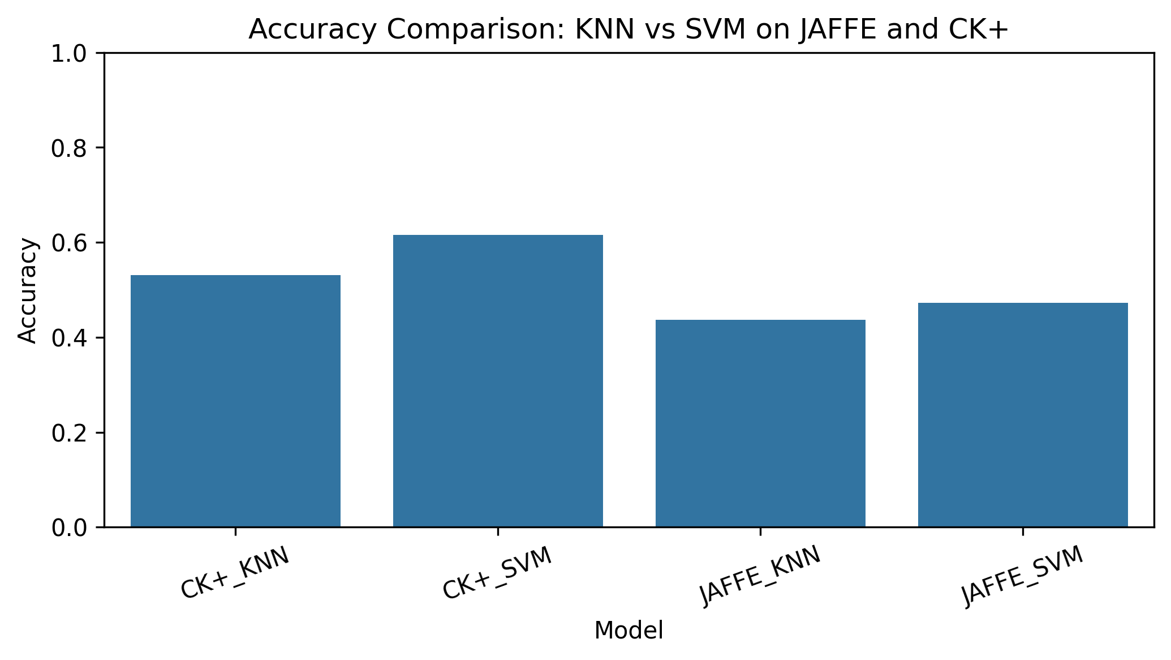

Figure 8: Correct vs incorrect predictions
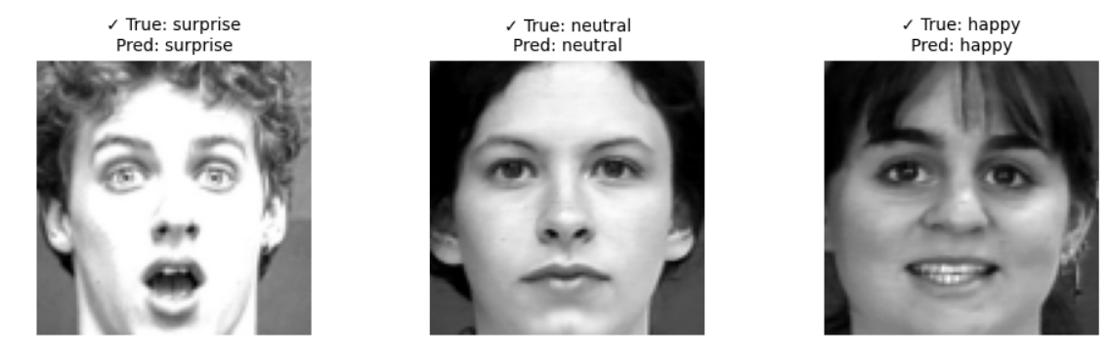
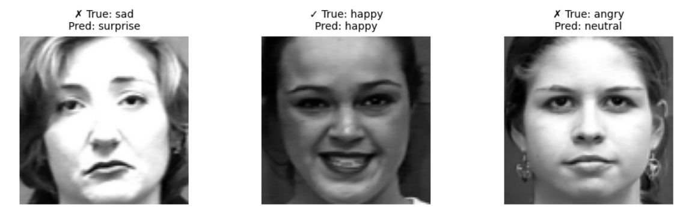

Appendix A: Dataset Label Corrections (Before and After)
A.1 Examples of Mislabelled Images Before Correction
The following images illustrate typical cases of misclassifications found during dataset inspection.
These images were originally placed in incorrect emotion folders:
- Image 1: Stored under Neutral, expression is clearly Angry.
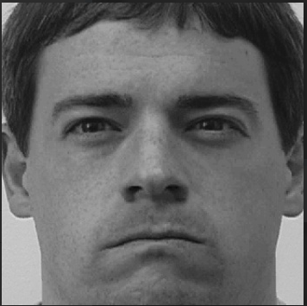
- Image 2: Stored under Surprise, expression is clearly Neutral.
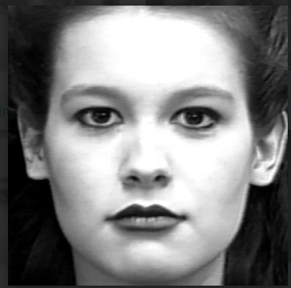
- Image 3: Stored under Neutral, expression is clearly Sad.
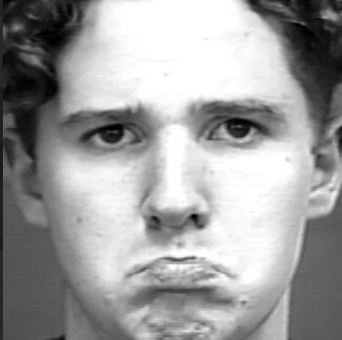
A.2 Corrected Labels After Manual Relabelling
The images shown above were relocated to the correct emotion folders after inspection:
- Image 1 → Moved to: Angry/
- Image 2 → Moved to: Neutral/
- Image 3 → Moved to: Sad/
This correction step improved dataset integrity and contributed to the improvement in SVM accuracy, especially on the CK+ dataset.

8. References (Harvard Style)
Akbulut, Y. and Mutlu, B. (2023) ‘Facial expression recognition based on improved histogram of oriented gradients and support vector machines’, Pattern Recognition Letters, 169, pp. 57–65. Available at: https://doi.org/10.1016/j.patrec.2023.04.004.
Cover, T. and Hart, P. (1967) ‘Nearest neighbour pattern classification’. IEEE Transactions on Information Theory, 13(1), pp. 21–27. Available at: https://doi.org/10.1109/TIT.1967.1053964.
Cortes, C. and Vapnik, V. (1995) ‘Support-vector networks’, Machine Learning, 20(3), pp. 273–297. Available at: https://doi.org/10.1007/BF00994018.
Dalal, N. and Triggs, B. (2005) ‘Histograms of oriented gradients for human detection’. In: Proceedings of the IEEE Computer Society Conference on Computer Vision and Pattern Recognition (CVPR). San Diego, CA: IEEE, pp. 886–893. Available at: https://doi.org/10.1109/CVPR.2005.177.
Happy, S.L., George, A. and Routray, A. (2015) ‘A real-time facial expression classification system using local binary patterns. IEEE Transactions on Affective Computing, 6(3), pp. 214–225. Available at: Paper Title (use style: paper title).
Lucey, P., Cohn, J.F., Kanade, T., Saragih, J., Ambadar, Z. and Matthews, I. (2010) ‘The Extended Cohn–Kanade (CK+) dataset: A complete dataset for facial expression analysis’, in 2010 IEEE Computer Society Conference on Computer Vision and Pattern Recognition Workshops (CVPRW). San Francisco, CA: IEEE, pp. 94–101. Available at: https://doi.org/10.1109/CVPRW.2010.5543262.
Li, S. and Deng, W. (2020) ‘Deep facial expression recognition: A survey’, IEEE Transactions on Affective Computing, 13(3), pp. 1195–1215. Available at: https://doi.org/10.1109/TAFFC.2020.2981446.
Subudhiray, S., Palo, H.K. and Das, N. (2022) ‘Efficient feature extraction for recognition of human emotions through facial expressions using image processing algorithms. Journal of Physics: Conference Series, 2267(1), 012015. Available at:10.11591/ijai. v12.i1.pp57-65.
Sariyanidi, E., Gunes, H. and Cavallaro, A. (2015) ‘Automatic analysis of facial affect: A survey of registration, representation, and recognition’. IEEE Transactions on Pattern Analysis and Machine Intelligence, 37(6), pp. 1113–1133. Available at: https://doi.org/10.1109/TPAMI.2014.2366127.
Tanjung, J.P. and Muhathir (2020) ‘Classification of facial expressions using SVM and HOG’. Journal of Informatics and Telecommunication Engineering, 3(2), pp. 76–80. Available at: https://doi.org/10.31289/jite.v3i2.3182.
Zhao, G. and Pietikäinen, M. (2007) 'Dynamic texture recognition using local binary patterns with an application to facial expressions'. IEEE Transactions on Pattern Analysis and Machine Intelligence, 29(6), pp. 915–928. Available at: https://doi.org/10.1109/TPAMI.2007.1093.

